**Q1) What are the main important attached to DOM? Explain each one briefly.**

* Properties are data elements of objects. For example for document object some properties are: bgcolor, title, URL
* Methods are built-in actions or functions that an object can perform. For example for document object one common method is: write(). We use document.write(‘Hello’).
* Most objects in the DOM have specific events to which they can respond. For example for form object we have onReset event that will fire when the text in textbox changes.

**Q2) write HTML code using JavaScript popup an alert has " HELLO WORD" Massage when clicking on a button**

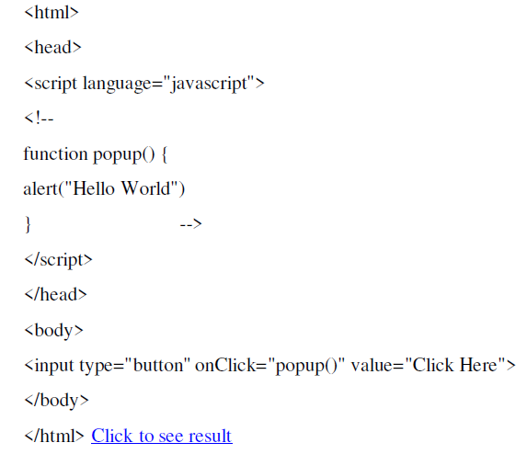

**q3) Write a JavaScript to detect the following properties of browser:**

**Browser type , if cookies enabled , the language being used.**

<html>

<body>

<p id="infoBrowser"></p>

<script>

document.getElementById("infoBrowser").innerHTML

="Broswer Type is "+navigator.userAgent

+" Cookie "+navigator.cookieEnabled

+" language: "+navigator.language;

</script>

</body>

</html>

**Q4) What is a dynamic web page? Why would we need a dynamic web page?**

* A dynamic web page is one that is crated at run time, on the fly by executing some programs then converting the output into HTML format and sending it to the bowers to interpret.
* Needed wherever we want to interact with the visitor. For example, search engine is a dynamic web application.
* Dynamic web page is needed in e-commerce applications.
* For a static web page a server simply locates a pre created html file saved on its hard disk and send it to browser to interpret.
* For a dynamic web page the server locates and execute a pre created program and sends the resulted HTML to browser.

**Q5) List and explain advantages and disadvantages of the three possibilities of making a web site dynamic ?**

* **Server side processing**: Server is responsible for executing a program (script) and then sends the results in HTML format to client (browser) to interpret.

**Advantages :**

* + 1. Application logic resides at one place (i.e. server).
    2. Ensures better security.

Ex: ASP and JSP.

* **Client side processing**: Refers to the processing done at the browser. The browser has two primary parts: the interface (which is the part we see) and the processing software (which is the part that we do not see). The browser interface still has to send messages, but it sends them internally to another part of the overall browser software.

**Advantages:**

* + Customize interaction with the user
  + Validate user input
  + It reduces the load on the web server.
  + Less information must travel between the server and the Client.
  + Saving time and bandwidth.

Ex: VBScript and JavaScript.

* **Mix of server side and client side processing**: a normal approach. Client side processing is used for formatting the page and validating the input. Secured info like user id and password should not be done on client side.

**Q6) How ASP works?**

* When a browser requests an HTML file, the server returns the file.
* Browser reads it and shows the result.
* When a browser requests an ASP file
  + Server passes the request to the ASP engine.
  + The ASP engine reads the ASP file, line by line, and executes the scripts in the file.
  + Finally, the ASP file is returned to the browser as plain HTML.

**Q7) What is namespaces in XML? How it could be used ?**

* Namespaces usually take the form of a URL, beginning with a domain name. an optional namespaces label in the form of a directory name and finally version number, which is also optional:

Xmlns= “http://www.mydomain.com/ns/animals/1.1”

* Used to provide a unique name for a document.

**Q8) write and compare between HTML and XML code for a book has the following data: title, first name of author, last name of author, publisher and year of publication**

**XML**

<book>

<title>Sense and Sensibility</title>

<fitstname>mshary </ fitstname >

<lastname>alharbi</lastname>

<publisher>jarir</publisher>

<year>1811</year>

</book>

**HTML**

<html>

<body>

<h2>Books</h2>

<hr>

<em>title</em>, <b> Internet Technology</b><br>

<em>fitstname</em>, <b> mshary</b><br>

<em>lastname</em>, <b> Alharbi</b><br>

<em>publisher</em><b> jarir</b><br>

<em>year</em> <b> 2017</b><br>

</body>

</html>

**Q9) What is an XSL?**

Stand for: Extensible stylesheet language. Includes two independent parts: a transformation language (XSLT) and formatting objects language (XSL:FO).

It is used to specify how something should be display/rendered, they lead to separation of documents content form presentational information.

**Q10) what is a web service ? what is the SOAP? Explain the SOAP elements briefly?**

A service that is platform independent, will work between systems that are distributed and can communicate through firewalls without raising security issues.

SOAP stands for Simple Object Access Protocol; it is a protocol for accessing web services based on XML.

* **SOAP Envelope Element** it's the root of SOAP message , defined the XML document as soap message
* **SOAP Header Element** its optional , its contains header information, its contains application-specific information(like payment, authentication)
* **SOAP Body Element** contains the actual SOAP message intended for the ultimate endpoint of the message
* **SOAP Fault Element** holds error, status information for a SOAP message. It is optional.